- Sand-Wave Modeling
- Introduction
- Model framework
2-1 Ocean model
2-2 Wave model
2-3 Sediment model
- Preliminary Example

- An integrated nearly real-time ocean-atmosphere observational and modelling platform
- Objectives
- Integrated nearly real-time ocean-atmosphere observational platform
2-1 Atmospheric wind measurements
2-2 Satellite SST and Chlorophyll-a product
2-3 Sea surface height
2-4 Sea surface current and wave measurement
- A Coupled Ocean-Atmosphere-Wave-Sediment Transport modelling system
3-1 COAWST model framework
3-2 The metocean data for the long-term design
3-3 Real-time forecasting system

Sand-Wave Modeling
1. Introduction
Acoustic backscatter studies have shown that the seabed in the Taiwan Strait (including the Hailong station 18 and 19) is extremely mobile, characterized by moving sand waves, dunes and ripples covering scales from centimeters to hundreds of meters in length and with height variations up to several meters (Cure, 2013). For the wind turbine installation, we have to know the characteristics of ocean seabed so that the mooring structures and associated seabed mounted cables will be stable, even in the strong typhoon conditions. Also, the presence of the mooring structures may affect the sediment dynamics. High seabed shear stresses can lead to scours developing around foundations and the movement of sand waves can bury or expose seabed mounted structures and moorings. This is likely to occur during the typhoon events, when large waves and tides can remobilize and transport the sediments. The mobile seabed (moving sand waves, dunes and rippers), which may influence the stability of wind turbine installation, is directly driven by the ocean current and wave induced shear stress. The sand-wave model is useful to assess the impacts of mobile seabed. The sand model involves two sediment transport mechanisms, bed load and suspension load, which can induce sediment erosion and deposition at the seabed and result in the migration of bedform. The wave model simulates the wind wave generation and propagation in the coastal waters, including the processes of refraction, diffraction, shoaling, wave–wave interactions, and dissipation due to whitecapping, wave breaking, and bottom friction. The sediment can be transported due to the bottom friction and feedback to waves by altering the shoaling. The sand-wave interaction needs to be considered in the coupled sand-wave model in order to capture the crucial feature of the seabed morphology. In this project, a sophisticated coupled sand-wave modeling framework is purposed to better model the offshore morphodynamics.
2 Model framework
The Coupled-Ocean-Atmosphere-Wave-Sediment Transport (COAWST) model is used here for the basic framework in this project. COAWST Modeling System is an agglomeration of open-source modeling components that has been tailored to investigate coupled processes of the atmosphere, ocean, and waves in the coastal ocean. The COAWST model uses the Model Coupling Toolkit to couple the WRF model, the Regional Ocean Modeling System (ROMS, Shchepetkin and McWilliams, 2005) with the Sediment Transport Model capability (Warner et al., 2010) and the Simulating WAves Nearshore (SWAN) wave model. All of the component models in COAWST are widely used regional models with a broad range of applications on scales ranging from meters to thousands of kilometers of the atmospheric and oceanic processes.
Currently COAWST has been used by approximately 100 groups around the world for a variety of users including hurricane research, coastal erosion research, renewable energy applications and the interaction of sediment laden riverine fluxes with the coastal environment, as well as the research of wind-wave interactions and other boundary layer phenomena. The coupled model is maintained by John Warner of the USGS and his team.
All of these models are designed to run on parallel processing computers. The way that COAWST works is that each model runs on a part of a supercomputer cluster, with an assigned number of CPU's and then periodically the models communicate with each other, swapping data in a two-way exchange, before recommencing. Typically, an application running COAWST will require the order of 100 CPU's. The use of COAWST requires a detailed knowledge of the component models. Getting the whole coupled model system to work properly is not a trivial task since the model operation is not independent of the computer system architecture.
In this project, a set of prescribed atmosphere data is used for the boundary condition in order to simplify the framework. The configuration of coupled framework used in this project is shown in Figure 1. The 3D currents are also modelled as well as the sediments. The resulting modelling system is coupled so that the waves interact with the currents and cause Stokes drift and injection of turbulent kinetic energy. The combined wave orbital motion and hydrodynamic currents resuspend and transport sediments, the shape of the sea bed alters so that the currents are affected and the currents also affect the surface waves whose energy flux is changed by them. The detail of the component models is described as below:
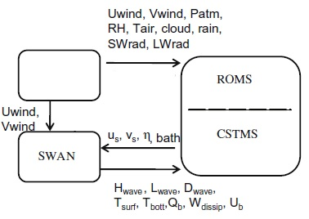
atmo. data
Figure 1 Model framework in this project
2-1 Ocean model
The ocean model is the Regional Ocean Modeling System (ROMS), a general class of free surface, terrain-following numerical models that solve the three dimensional Reynolds-averaged Navier–Stokes equations (RANS) using the hydrostatic and Boussinesq approximations (Shchepetkin and McWilliams, 2005, 2009; Haidvogel et al., 2008). ROMS uses finite-difference approximations on a horizontal curvilinear Arakawa C grid and on a vertical stretched terrain-following coordinate. Momentum and scalar advection and diffusive processes are solved using transport equations and an equation of state computes the density field that accounts for temperature, salinity, and suspended-sediment contributions. ROMS provides a flexible structure that allows multiple choices for many of the model components such as several options for advection schemes (second order, third order, fourth order, and positive definite), turbulence models, lateral boundary conditions, bottom- and surface-boundary layer submodels, air–sea fluxes, surface drifters, a nutrient-phytoplankton-zooplankton model, and an adjoint model for computing model inverses and data assimilation. The code is written in Fortran90 and runs in serial mode on a single processor, or uses either shared- or distributed- memory architectures (OpenMP or MPI) to run on multiple processors.
2-2 Wave model
The wave model is Simulating WAves Nearshore (SWAN). SWAN is a spectral wave model specifically designed for shallow water that solves the spectral density evolution equation (Booijet al., 1999). SWAN simulates wind wave generation and propagation in coastal waters and includes the processes of refraction, diffraction, shoaling, wave–wave interactions, and dissipation due to whitecapping, wave breaking, and bottom friction. The wave model solves the action balance equation (Holthuijsen, 2008):
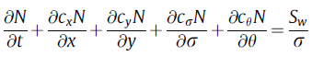
where N(r, h, x, y, t) is the action density spectrum, r is the relative radian frequency (as observed in a frame moving with the ocean current), h is direction normal to the wave crest, x and y are coordinate space (expressible in both spherical and Cartesian coordinates), and t is time. The action density is defined as the wave energy density (E) divided by the relative frequency (N = E/sigma) and is solved because action density is conserved in the presence of currents. The group velocities in x- and y-directions cx and cy in the second and third terms represent propagation of action density in geographic space, the fourth term represents changes in relative frequency due to variations in depth and currents with a propagation speed cr in frequency space, and the fifth term allows depthand current-induced refraction with a speed ch in directional space.
2-3 Sediment model
The sediment modeling component is from the Community Sediment Transport Modeling System (CSTMS; Warner et al., 2008b). Currently these components are integrated into the ROMS model. However, they are identified as a separate set of routines and can be extracted as a separate entity. The sediment routines consist of algorithms for suspended-sediment transport, bed load transport for current and wave–current forcing, enhanced bottom stress due to surface waves, a multiple bed model to track stratigraphy, morphology, and the ability to transport multiple sediment classes. These routines have been demonstrated to simulate a variety of inner shelf and estuarine sediment processes (Warner et al., 2008a; Harris et al., 2008; Ganju et al., 2009).
The sediment transport model allows an arbitrary number of sediment layers, each of which can contain combinations of the main sediment classes. The different sediment layers mix with each other, thus varying the sediment properties in each. The sediment at the sea surface can be resuspended and be transported within the water column, or it can be transported as a bedload. Optionally sediments with organic components can be included, although this has not been done here in this high energy environment.
The sediment model extends the concept of the 3D model into the sediments themselves with an arbitrary number of layers. The sediment model layering is shown in Figure 2.

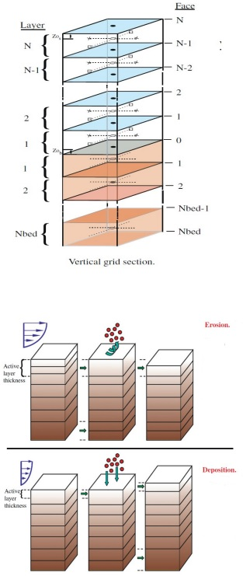
Figure 2. Sediment layer discretization in COAWST model

3. Preliminary Example
This preliminary example tests the evolution of windfarm topography in the coupled ocean (ROMS) and wave (SWAN) configuration for an idealized experiment. The model is driven by a sinusoidal water level on the northern edge and waves are developed from the north with a 1m height propagating towards the south. Flow pattern is shown below:
All of the grids and input files have already been created for this application and are available in Projects/Inlet_test/Coupled. Here is a basic set of steps required to make these files and run this application.
- Use create_roms_xygrid.m to create the roms and swan grids. These are simple rectangular grids and can be created easily with these tools. User sets the x/y locations, depth, and masking. This m file calls mat2roms_mw to create the roms grid file called inlet_test_grid.nc and calls roms2swan to create the swan grid files. The swan grid files were renamed to inlet_test_grid_coord.grd and inlet_test_bathy.bot.
- For this case, we are initializing the roms model from rest, so we are relying on ANA_INITIAL default values. The m file create_roms_init could be used to create a more complicated set of init conditions. We are also using ana_sediment to create a uniform field of 10m thick bed with porosity=0.5 and 1 grain size. This could have been created with the create_roms_init file as well. The file sediment_inlet_test.in lists some sediment properties for this application.
- For this case we are initializing SWAN from rest so there are no swan init files. we could have run swan for with some wind field, but this case has no winds.
- Create the header file: Edit inlet_test.h to see the options selected for this application. we needed to define
#define ROMS_MODEL
#define SWAN_MODEL
#define MCT_LIB
, as well as several boundary conditions and wave current interaction (WEC) options, the wave-enhanced bottom boundary layer option (SSW_BBL), GLS_MIXING, and some sediment options of suspended load and bed morphology updating.
- Determine settings for roms and swan in the ocean_inlet_test.in and swan_inlet_test.in. These are some standard options in these files.
- Create the coupling file called coupling_inlet_test.in to enter the roms and swan input file names and determine the coupling interval.
- Edit the coawst.bash file to build this application.
- Compile and run.
The simulating bedform migration of the preliminary test is shown in Figure 3. Since the scale of bedform may cover a wild range which is larger than the windfarm area, a bigger domain with extended seabed topography around the windfarm is considered in the further simulation. Table 1 list 5 sea bed topography resource been used to augment the domain in further simulation. Figure 4 shows the comparison of different seabed topography resource.
(c)
(b)
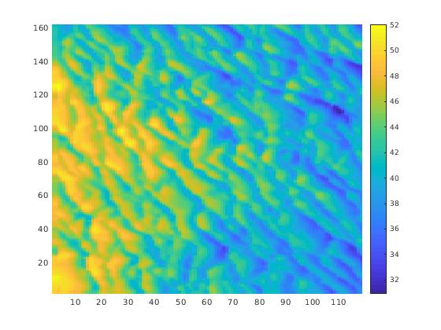  (a) | 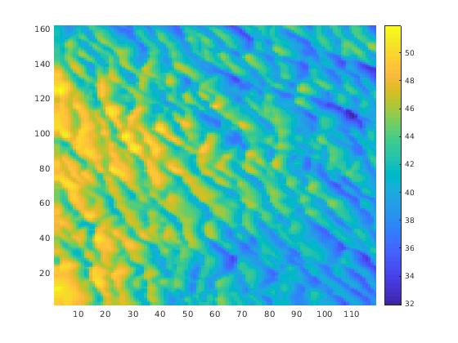 | 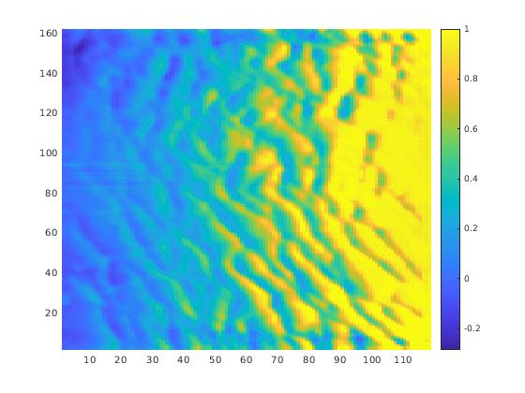
Figure 3. bedform migration in preliminary test, (a) initial bedform, (b) bedform in 8 hours, (c) bedform variation in 8 hours.

Table 1 the collected terrain data resource
resource | Resolution | range
DBDB2 | 2min.(3.6km) | 0 ~ 60 N  100 ~150 E
ETOPO2 | 2min.(3.6km) | global
GEBCO | 30sec.(0.9km) | global
TW500m | 500meter | 18 ~ 27 N  117 ~ 125 E
TW200m | 200meter | 21 ~ 26 N  119 ~ 123 E

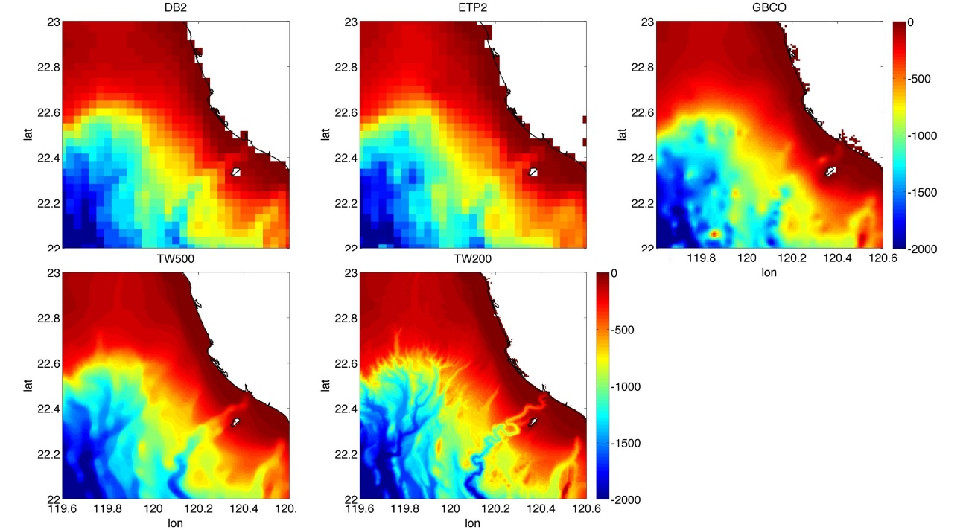
Figure 4. comparison of different seabed topography resource

Reference
Booij, N., Ris, R.C., Holthuijsen, L.H., 1999. A third-generation wave model for coastal regions. Part I: Model description and validation, Journal of Geophysical Research, 104(C4), 7649–7666.
Ganju, N.K., Schoellhamer, D.H., Jaffe, B.E., 2009. Hindcasting of decadal-timescale estuarine bathymetric change with a tidal-timescale model. Journal of Geophysical Research, 114, F04019. doi:10.1029/2008JF001191.
Haidvogel, D.B., Arango, H.G., Budgell, W.P., Cornuelle, B.D., Curchitser, E., Di Lorenzo, E., Fennel, K., Geyer, W.R., Hermann, A.J., Lanerolle, L., Levin, J., McWilliams, J.C., Miller, A.J., Moore, A.M., Powell, T.M., Shchepetkin, A.F., Sherwood, C.R., Signell, R.P., Warner, J.C., Wilkin, J., 2008. Regional ocean forecasting in terrain-following coordinates: model formulation and skill assessment, Journal of Computational Physics, 227, 3595–3624.
Harris, C.K., Sherwood, C.R., Signell, R.P., Bever, A., Warner, J.C., 2008. Sediment dispersal in the northwestern Adriatic Sea. Journal of Geophysical Research, Oceans, 113, C11S03. doi:10.1029/2006JC003868
Holthuijsen, L.H., 2008. Waves in Oceanic and Coastal Waters, Cambridge Press, 387.
Marcel Cure, 2013, A Study of the Effect on Seabed Sediments at Ocean Energy Sites of Storm Waves and Currents using a Coupled Wave and Hydrodynamic Numerical Model – Final Report, Sediment Storm Model for INFOMER, Numerics Warehouse Ltd.
Shchepetkin, A.F., McWilliams, J.C., 2005. The Regional Ocean Modeling System: a split-explicit, free-surface, topography-following coordinates ocean model, Ocean Modelling, 9, 347–404.
Shchepetkin, A.F., McWilliams, J.C., 2009. Correction and commentary for ‘‘Ocean forecasting in terrain-following coordinates: Formulation and skill assessment of the regional ocean modeling system” by Haidvogel et al., J. Comp. Phys. 227, pp. 3595–3624.”. Journal of Computational Physics, 228, 8985–9000.
Warner, J.C., Butman, B., Alexander, P.S., 2008a. Storm-driven sediment transport in Massachusetts Bay. Continental Shelf Research, 28, 257–282.

An integrated nearly real-time ocean-atmosphere observational and modelling platform
- Objectives
Taiwan Strait connects the East China Sea and South China Sea, playing an important role on the water and heat exchange between both regional seas. Taiwan Strait is under the influence of the East Asia monsoon. The northeasterly winds in winter may be very strong sometimes. In addition, an average of 3-5 typhoons (tropical storms) pass by the nearby region every year. The complicated topography in the Taiwan Strait greatly affects the physical process of current-wave interaction of different space and time scales, leading to various unique ocean phenomenon in this region. For example, Jan (2004) demonstrated that the wave reflection of southward propagating tidal wave by the deep trench in the southern strait caused a complex wave propagation pattern, resulting in wave resonance around the center of the strait (Figure 1). Chang (2010) found that the typhoon-induced surface flows is amplified by the long, narrow geometry of the Taiwan Strait. The surface currents generated by wind forcing due to the passage of a traveling typhoon can be explained by the Ekman drift. Zhang (2010) suggested that the strong tidal currents and storm‐induced currents along the channel might enhance the tide‐surge interaction via the nonlinear bottom friction, resulting in the strong oscillations along the northern Taiwan Strait. Extreme weather event can also triggered terrestrial materials from the west Taiwan transported to the region northeast of Taiwan (He et al. 2014). Figure 2 shows the composite satellite‐derived transparency images after Typhoon Morakot (2009) and the Schematic map of the three sources of turbid waters transported to the region off northeastern Taiwan triggered by the typhoon Morakot. These results suggested the sediment aggregation and movement in the Taiwan Strait are substantial due to the severe environments.
Therefore, we propose to a) establish an integrated and completed real-time observational database to provide the higher quality environment information for cost analysis, overall design, construction and risk assessment. The information includes the quality-controlled atmospheric fields, ocean surface conditions and subsurface currents and sand movements. The completed metocean information can be monitored in real-time and any decision can be quickly made on the remote land station. b) develop a fully coupled real-time forecasting model to accurately evaluate the scenario of severe events and optimize the strategy during the operation. The fully coupled real-time forecasting system provides the completed and detailed three-dimensional atmospheric and oceanic conditions for the offshore wind farm.
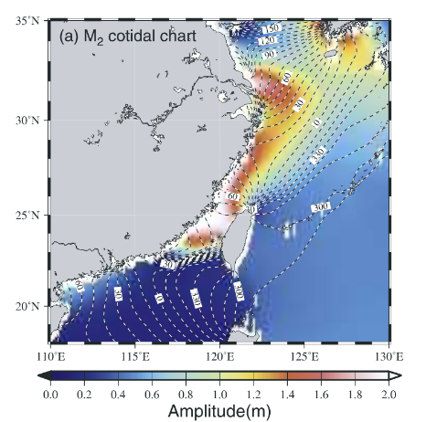
Figure 1. co‐tidal chart of the simulated M₂tide. The co‐phase lines in indicate westward propagation of tidal waves in the northwest Pacific with amplitude of about 0.5 m. (Jan et al. 2004)
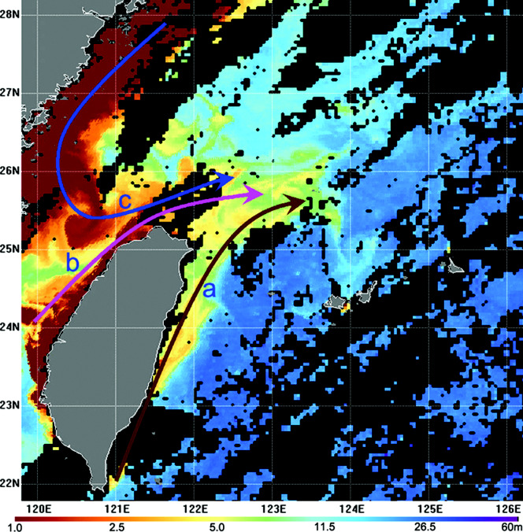
Figure 2. the composite satellite‐derived transparency images after Typhoon Morakot (2009) and the Schematic map of the three sources of turbid waters transported to the region off northeastern Taiwan triggered by Morakot

- Integrated nearly real-time ocean-atmosphere observational platform
Overall, the oceanic dynamic in the Taiwan Strait involving strong interaction between atmosphere, ocean, tide, wave and topography. To obtain the time and space varying ocean conditions for Site 18/19, near-real-time ocean and atmosphere observation data and a wave-ocean-sediment coupled model is required. An integrated ocean-atmosphere observational platform is thus planed for the future operation at site 18/19. The work requires to obtain the remote-sensed data, Lidar and codar data, CWB buoy station data and an in-situ mooring station at 18/19 which we can manage directly. The work includes the calibration, validation and tuning because all of these data. The detail of these data sets is introduced below:
2-1 Atmospheric wind measurements
- LIDAR (light detection and ranging) is a remote wind sensing technology that measures distance to a target with pulsed laser light and measuring the reflected pulses with a sensor. The atmospheric particles reflect the laser light back towards the receiver of the system along the beam path. Based on the optical Doppler effect, LIDAR can retrieve the complete wind vector. Differences in laser return times and wavelengths can then be used to make digital 3-D representations of the target. The accuracy of LIDAR systems has been tested against meteorological masts with wind sensors in both onshore and offshore settings (Standridge et al., 2007; Jaynes et al 2007).
- Scatterometer: A scatterometer or diffusionmeter is a scientific instrument to measure the return of a beam of light or radar waves scattered by diffusion in a medium such as air. Diffusionmeters using visible light are found in airports or along roads to measure horizontal visibility. Radar scatterometers use radio or microwaves to determine the normalized radar cross section (σ0, "sigma zero" or "sigma naught") of a surface. They are often mounted on weather satellites to find wind speed and direction, and are used in industries to analyze the roughness of surfaces.
2-2 Satellite SST and Chlorophyll-a product
Sea Surface Temperature(SST) and Chlorophyll-a are useful to detect the surface tracer transport, fishery aggregation, ocean primary productivity and movement in real-time. This can also connect to the understanding of the ocean marine life. The Group for High Resolution Sea Surface Temperature (GHRSST) is an open international science group that promotes the application of satellites for monitoring sea surface temperature (SST) by enabling SST data producers, users and scientists to collaborate within an agreed framework of best practice. GHRSST provides a framework for SST data sharing, best practices for data processing and a forum for scientific dialog, bringing SST to the user. Figure 3 shows GHRSST image around Taiwan in 2018/11.
For the Global Ocean and Atlantic Satellite Observations, ACRI-ST company (Sophia Antipolis, France) is providing Chlorophyll-a products based on the Copernicus-GlobColour processor. For Global, different temporal resolutions are available: Daily, 8-days, Monthly, Climatology and in complement an estimation of the daily cloudless fields (based on an Optimal-Interpolation approach). Sensors used are SeaWiFS, MODIS-Aqua, MERIS, VIIRSN and OLCI-S3A. Global products are available at 4km, 25km and 100km of resolution. The Optimal Interpolation product is also available at 1km over Atlantic. The products can be downloaded from the CMEMS catalogue using different protocol. Figure 4 shows Chlorophyll-a around Taiwan in 2018/11.
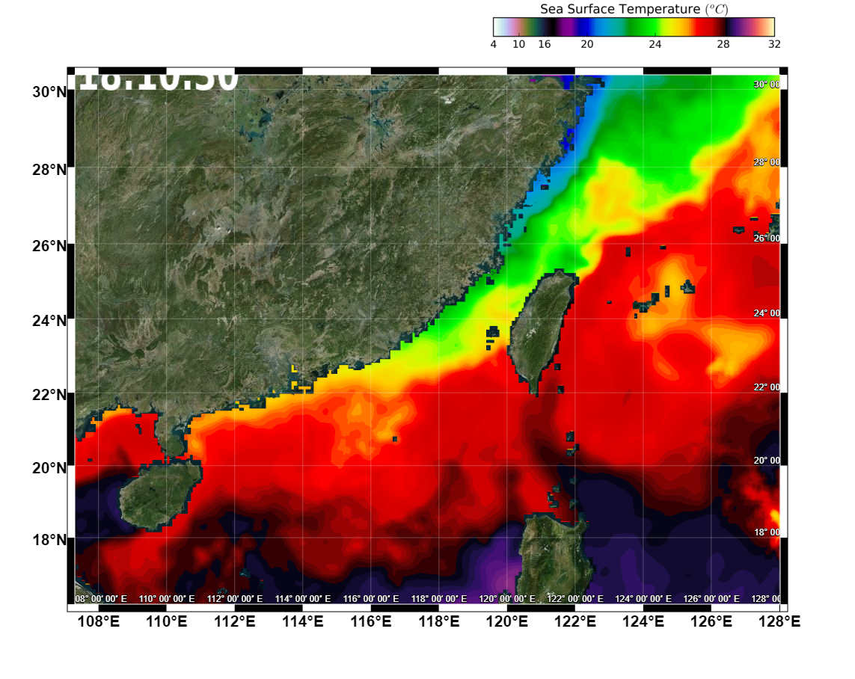
Figure 3. GHRSST image around Taiwan (2018/11).

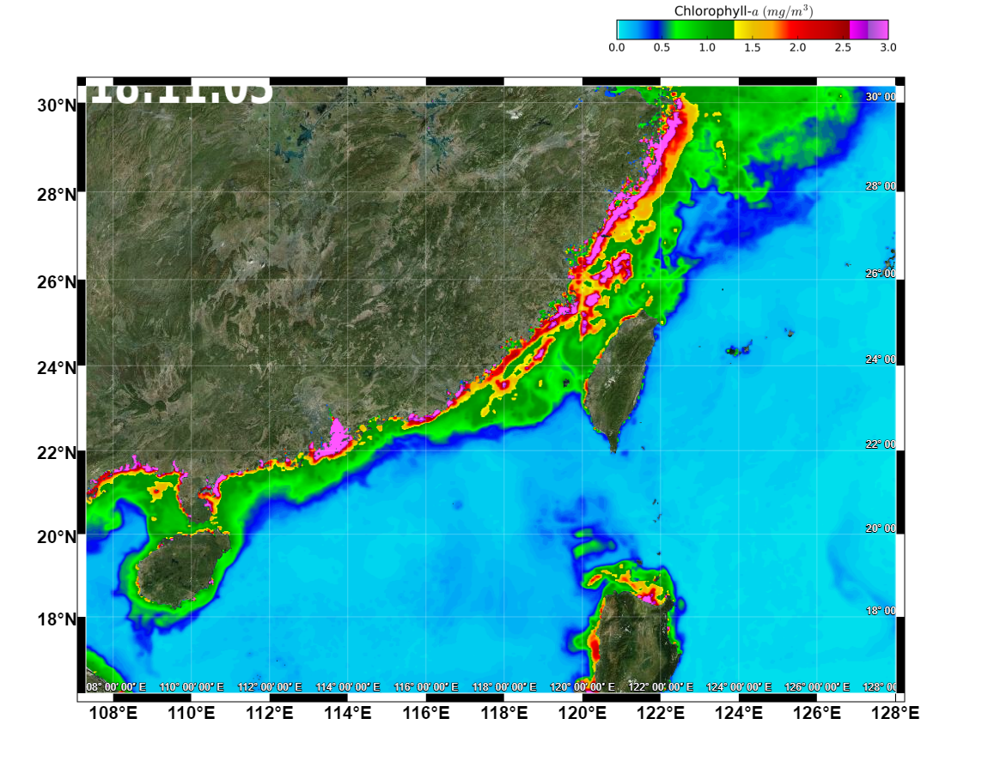
Figure 4. Chlorophyll-a around Taiwan (2018/11).
2-3 Sea surface height
Sea surface waves are critical for the severe weather impacts on the offshore wind farm foundation. Monitoring the ocean surface waves requires a good sea level information. Precise monitoring of changes in the sea level of the oceans, particularly through the use of altimetry satellites, is very important to understand not only the sea level variability but also the socioeconomic consequences of any change in sea level. Since January 1993, many altimetry satellites (e.g., Topex/Poseidon--Jason-1, Jason-1--Jason-2, then Jason-3--Jason-2) have been deployed to verify the altimetry data and correct the observational biases. Saral, Envisat, ERS-1 and ERS-2 are also used, after being adjusted on these reference missions, in order to compute the sea level at high latitudes (higher than 66°N and S), and also to improve spatial resolution by combining all these missions together. In addition, permanent monitoring of quality during the missions (Calval) and studies of the necessary corrections of altimetry data regularly add to our understanding and knowledge (see the Processing and corrections applied to each mission to obtain the reference mean sea level). An expression of sea surface height and the geostrophic current around Taiwan in 2018/11 are showed as Figure 5.

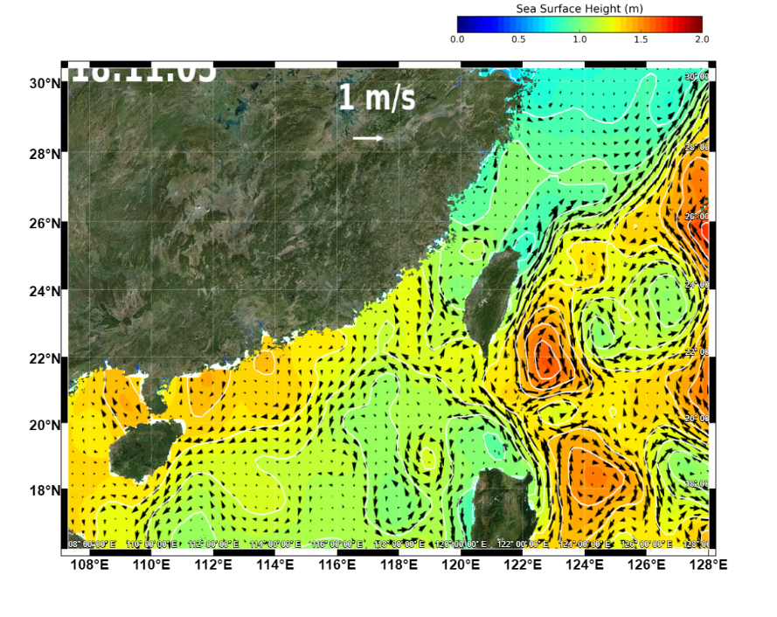
Figure 5. sea surface height and the geostrophic current around Taiwan (2018/11)
2.4 Sea surface current and wave measurement
Coastal ocean dynamics applications radar (CODAR) is a noninvasive system that permits to measure and map near-surface ocean currents in coastal waters. It is transportable and offers output ocean current maps on site in near real time. Moreover, it is possible to measure surface wave heights using CODAR. The CODAR can also provide an indirect estimate of local wind direction but surface currents is the primary result. Ranges achieved and resolution vary with environmental conditions and antenna placement. In general, however, in their long-range mode, modern CODAR can measure out to 100–200 km offshore with a resolution of 3–12 km. By increasing the frequency, resolutions as fine as 200–500 m can be obtained, but the observation range is shortened (15–20 km). However, the actual range can be limited by radio interferences, high-ocean states and ground conditions in the vicinity of the antennas. Wet and moist sandy soils enhance the ground wave propagation, whereas dry and rocky grounds reduce signal strengths. A single CODAR system can measure only the component of surface current travelling toward or away from the radar so, to determinate the total surface current vectors, it is necessary to use at least a two-systems set up. A series of CODAR sites can be employed to obtain regional coverage. In a multiple radar configuration, spacing between two radar systems should be approximately 15 to 40 km for long-range open ocean mode and 8 to 20 km for “higher frequency, higher resolution, shorter range” mode. Typically, CODAR data are averaged over one hour to reduce the noisiness of the sea echo. Therefore, current maps can be produced every hour. This period can be reduced to approximately 20 minutes, however the data may become noisy over such a short period. The CODAR data located at the east coast of Taiwan has been validated by comparing with flowing speed of SVP drifters (Fan et al. 2011; Kuo et al. 2014). SVP drifters were deployed through the GDP project (Global Drifter Program). They are equipped with drogues centered at 15 m depth, allowing them to follow the near-surface flow, and transmit their geographical position at 6-hour interval. The near-surface current velocity at each time is then determined through differentiation of the drifters' position with respect to the time elapsed between two transmissions. The comparison of near-surface current velocities at 15m depth derived from svp and surface flow measured by CODAR systems is showed in Figure 6.
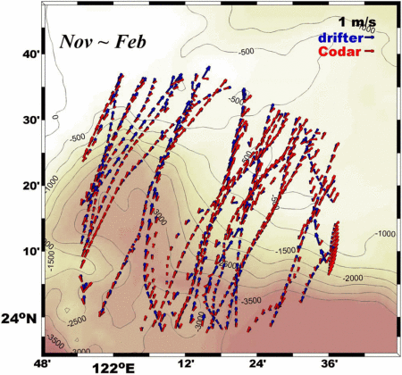
Figure 6. Comparison of near-surface current velocities at 15 m depth derived from svp drifter trajectories (blue) and surface flow measured by codar systems at the same time (red) during november to february. (Kuo et al. 2014)
2.5 In situ real-​time data buoy at site 18/19 and from CWB buoy stations
During a typhoon event, the evaluation of the sea state beneath the surface is important for prediction the ocean response. Thus besides the satellite sensing, a real-​time data buoy network is necessary. To establish a high density of buoy stations requires a large number of reliable instruments, as well as considerable support in the form of mooring supplies, satellite communications, and ship time (Jan et al. 2017). The new data acquisition system accommodates more meteorological and oceanic sensors than a standard Autonomous Temperature Line Acquisition System (ATLAS) (Hayes et al., 1991) mooring and can transmit data at adjustable intervals via satellite-​to-​ground stations. Our team, composed of scientists and technicians at National Taiwan University (NTU), actually maintains our the completed buoy system offshore of Taiwan (http://bit.ly/NTU​-data​-buoys) and help the Central Weather Bureau (CWB) to implement several marine buoy stations for measuring and monitoring nearly real-time coastal waves and currents, sea levels, and temperatures of the waters in the vicinity of Taiwan. Figure 7 is the location of in situ station. Of which sea level measurement and coastal data buoy networks have been established. We will collect the air-sea flux, ocean and atmospheric data and send back to the land station in real-time. Figure 8 displays the photo of buoy station and the processing of collected data.
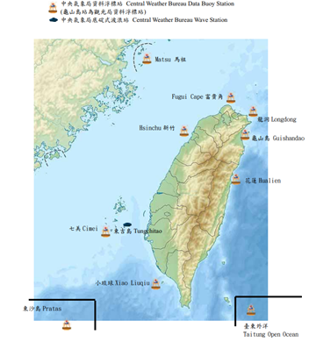
Figure 7. distribution of CWB buoy station.

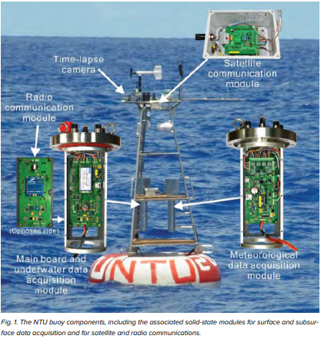 | 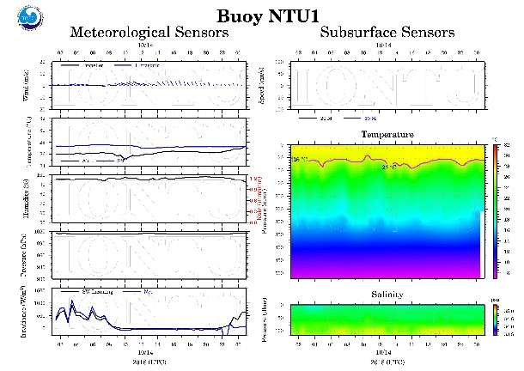
Figure 8. (a)the photo of buoy station and (b) data processing

A major component of the buoy system is an acoustic Doppler current profiler (ADCP). The ADCP is a hydroacoustic current meter similar to a sonar, used to measure water current velocities over a depth range using the Doppler effect of sound waves scattered back from particles within the water column. ADCPs contain piezoelectric transducers to transmit and receive sound signals. The traveling time of sound waves gives an estimate of the distance. The frequency shift of the echo is proportional to the water velocity along the acoustic path.
By adjusting the window where the Doppler shift is calculated, it is possible to measure the relative velocity between the instrument and the bottom. This feature is referred to as bottom-track. Bottom track provides the foundation for surveys of the water currents in coastal areas. In deep water where the acoustic signals cannot reach the bottom, the ship velocity is estimated from a more complex combination of velocity and heading information from GPS, gyro, etc. Some ADCPs can be configured to measure surface wave height and direction. The wave height is estimated with a vertical beam that measures the distance to the surface using the echo from short pulses and simple peak estimation algorithms. The wave direction is found by cross correlating the along-beam velocity estimates and the wave height measurement from the vertical beam. Wave measurements are typically available for seafloor-mounted instruments but recent improvements permit the instrument to be mounted also on rotating subsurface buoys.
Figure 9 shows a 20 year (1991–2011) historical ADCP data set showing the climatological current velocity at 30m depth around Taiwan collected by the Ocean Data Bank of the Ministry of Science and Technology (MOST), Taiwan.
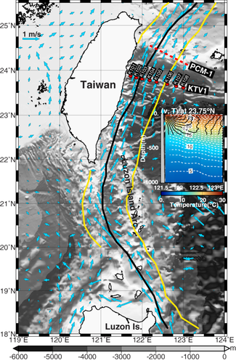
Figure 9. the climatological current velocity (blue arrows) at 30 m depth computed from the historical ADCP data set of Tawain's Ocean Data Bank.(Jan et al. 2015).
- An integrated coupled ocean-atmosphere-wave-sediment transport modelling system
A coupled ocean-atmosphere-wave-sediment transport modelling system is aimed to provide a more completed and detailed information of environmental variables which are interacted nonlinearly with each other. The integrated modelling system can greatly help to evaluate the costs and benefits relating to the offshore wind farm construction, and operation without the huge expense of seagoing exploration. Although all of the environmental variables can be estimated using different modelling tools, the lack of coupling feature, however, will lead to the lack of crucial detail and interaction to make an accurate assessment, especially for the long-term design.
The challenges of conducting the coupled model for the offshore windfarm is to correctly simulate the evolution of sea bedform under wind turbine foundation. This requires a high-resolution three-dimension terrain, better simulation of the surface waves in resuspending the sediments with the impacts of ocean currents, waves and tides and many others. The various physical processes associated with wave dynamics, tides, ocean currents, wind stress and riverine influences cannot be taken care individually in a satisfactory sense.
In order to simulate all of the important processes, numerical models have to be run concurrently. Recent advances in computer power through parallel processing together with advances in coupled hydrodynamic-wave-sediment models has brought these goals within reach and it is the intention of this study to investigate whether the numerical models are sufficiently advanced to be useful as a tool for engineers planning offshore installations – to help them select the best sites with the least dynamic sediments and to design appropriate structures.
The integral coupled model is used so that the waves interact with the currents and cause Stokes drift and injection of turbulent kinetic energy. The combined wave orbital motion and hydrodynamic currents resuspend and transport sediments, the shape of the sea bed alters so that the currents are affected and the currents also affect the surface waves whose energy flux is changed by them.
3-1 COAWST model framework
The Coupled-Ocean-Atmosphere-Wave-Sediment Transport (COAWST) Modeling System collects open-source modeling components for investigating coupled processes of the atmosphere, ocean, and waves in the coastal ocean. The modeling system contains a Coupler, Model Coupling Toolkit (MCT), an ocean model, Regional Ocean Modeling System (ROMS), an atmosphere model, Weather Research and Forecasting Model (WRF), a wave model, Simulating Waves Nearshore (SWAN), and Community Sediment Transport Modeling Systems (CSTMS).
WRF is the NOAA Weather Research Forecasting system and is a highly sophisticated numerical weather prediction system and which is currently being used by a number of national weather centres for their weather forecasts. SWAN (www.swan.tudelft.nl) is a shallow water spectral wave model. It is a so called 3rd generation model and includes many shallow water processes such as the interation of waves with the seabed, wave-wave interactions, wave breaking dissipation of energy and wave refraction. SWAN is used by many national forecasting centres. ROMS (the Regional Ocean Modeling System, www.myroms.org ) is the most widely used 3D ocean model. It is supported by a very large user community and has many modules for specific applications such as for storm surge, ice dynamics, biological models and variational data assimilation. It has many different advection schemes, boundary and surface forcing treatments and turbulent diffusion schemes.
The sediment model extends the concept of the 3D model into the sediments themselves with an arbitrary number of layers. In the sediment model, sediment is represented using separate cohesive and non-cohesive categories, each with an unlimited number of user-defined size classes. Each class has fixed attributes of grain diameter, density, settling velocity, critical shear stress for erosion, and erodibility constant. These properties are used to help determine the bulk properties of each bed layer. Most of the information in this section is also presented in Warner, Sherwood, Signell, Harris, and Arango, 2008 "Development of a three-dimensional, regional, coupled wave, current, and sediment-transport model", Computers & Geosciences. Cohesive sediment dynamics (i.e. consolidation, flocculation) have been implemented in development branches and are presently being migrated to the trunk. For more information, contact Chris Sherwood. Figure 10 shows the model set up in the COAWST. The MCT coupler send/receive the momentum, heat and mass flus transfer between the model components.
The result of COAWST simulation in the Taiwan Strait and the South China Sea have been validated using the atmospheric reanalysis data, the Argo drifter measurement and the satellite observation. Figure 11 compares the temperature and salinity profile (from sea surface to 500m depth) from COAWST model results and the Argos drifter measurement during 2016 spring and summer. The model simulation starts at 2015/11. Figure 12 shows the COAWST simulation of the typhoon–Kuroshio interaction during typhoon Nanmadol (2011). The cooling of the sea surface, which was associated with frontal movement in the LS, significantly reduced the intensity of the typhoon. The improved predictions of Nanmodal’s intensity resulting from this complex interaction between the ocean and atmosphere occur only in model runs which include full two-way coupling between oceanic and atmospheric processes (Kuo et al. 2018).
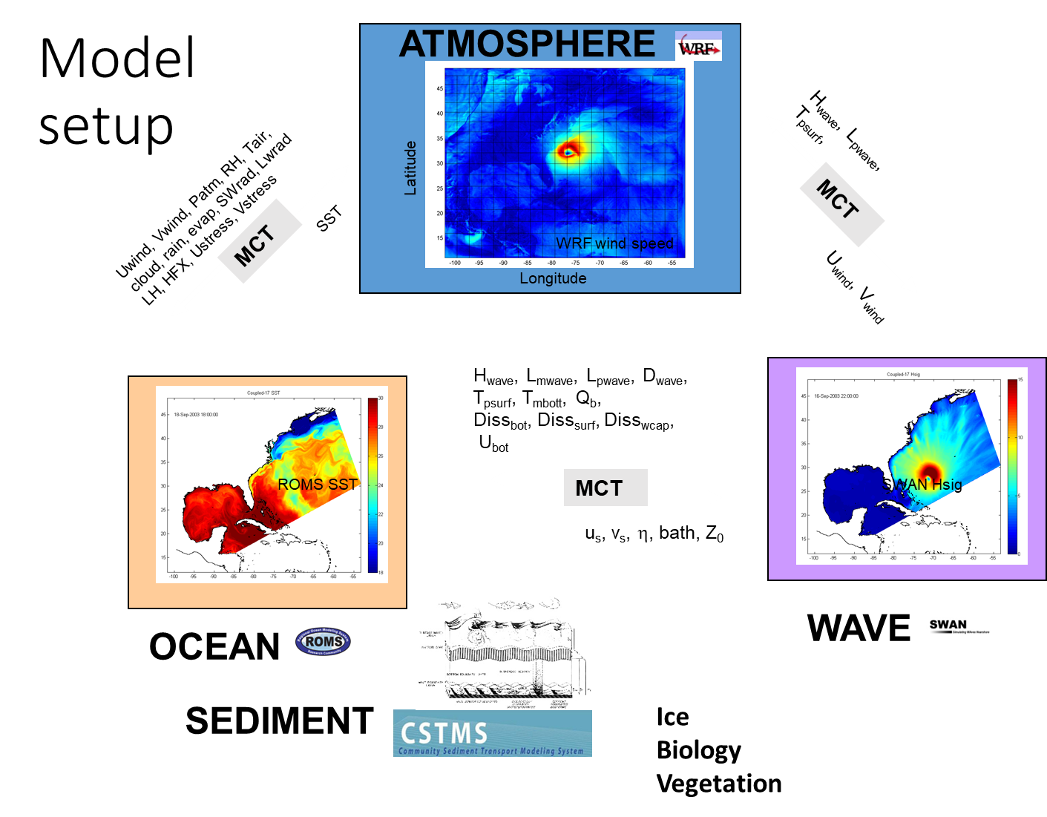
Figure 10. COAWST model set up.
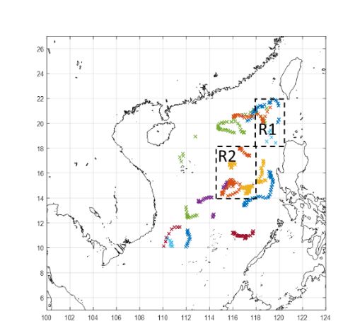
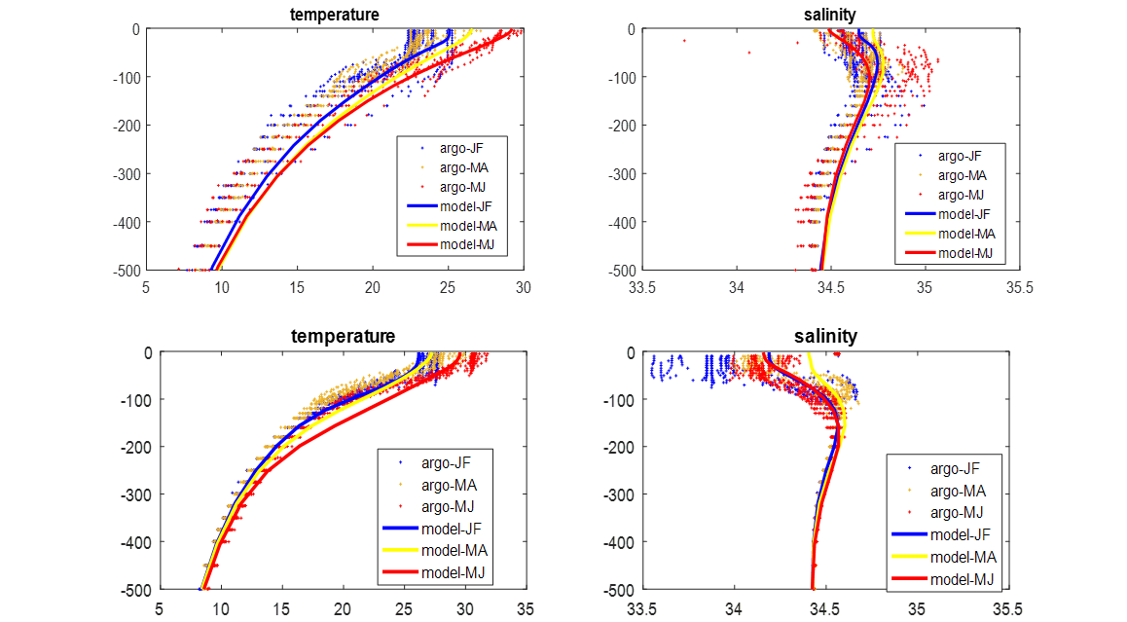
Figure 11. (top) Available trajectories of the Argo floats between 2016/1 and 2016/6. (middle-bottom) the T-S profiles averaged over the regions R1 and R2, respecrively.
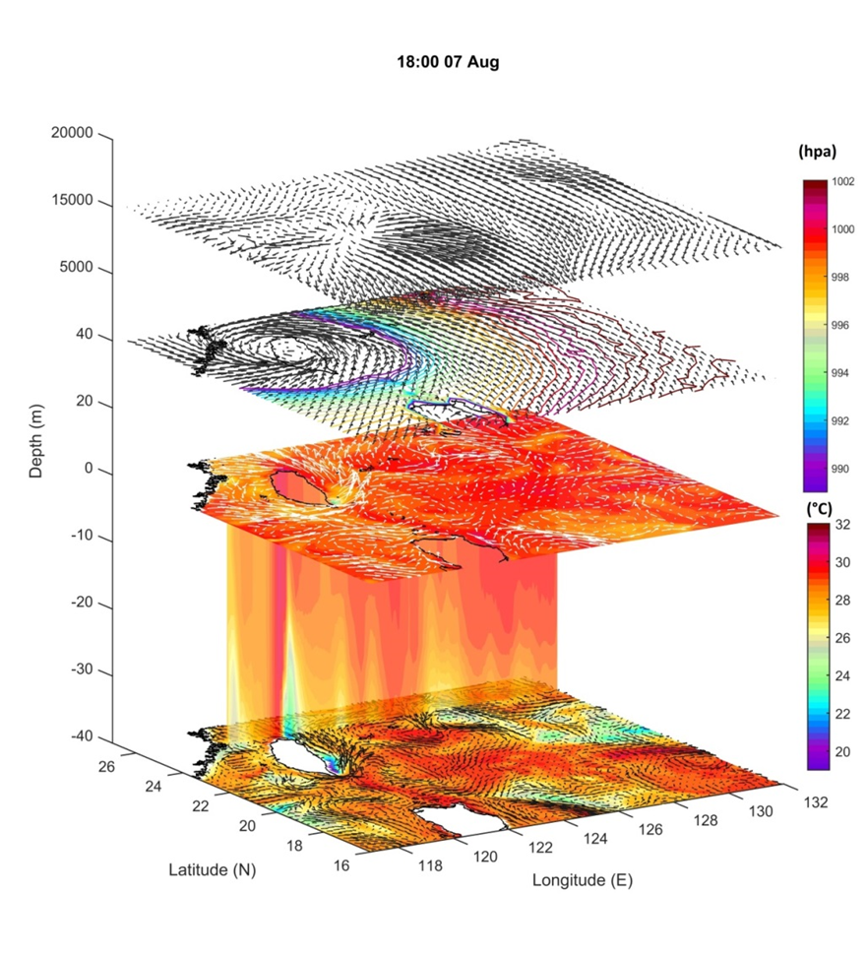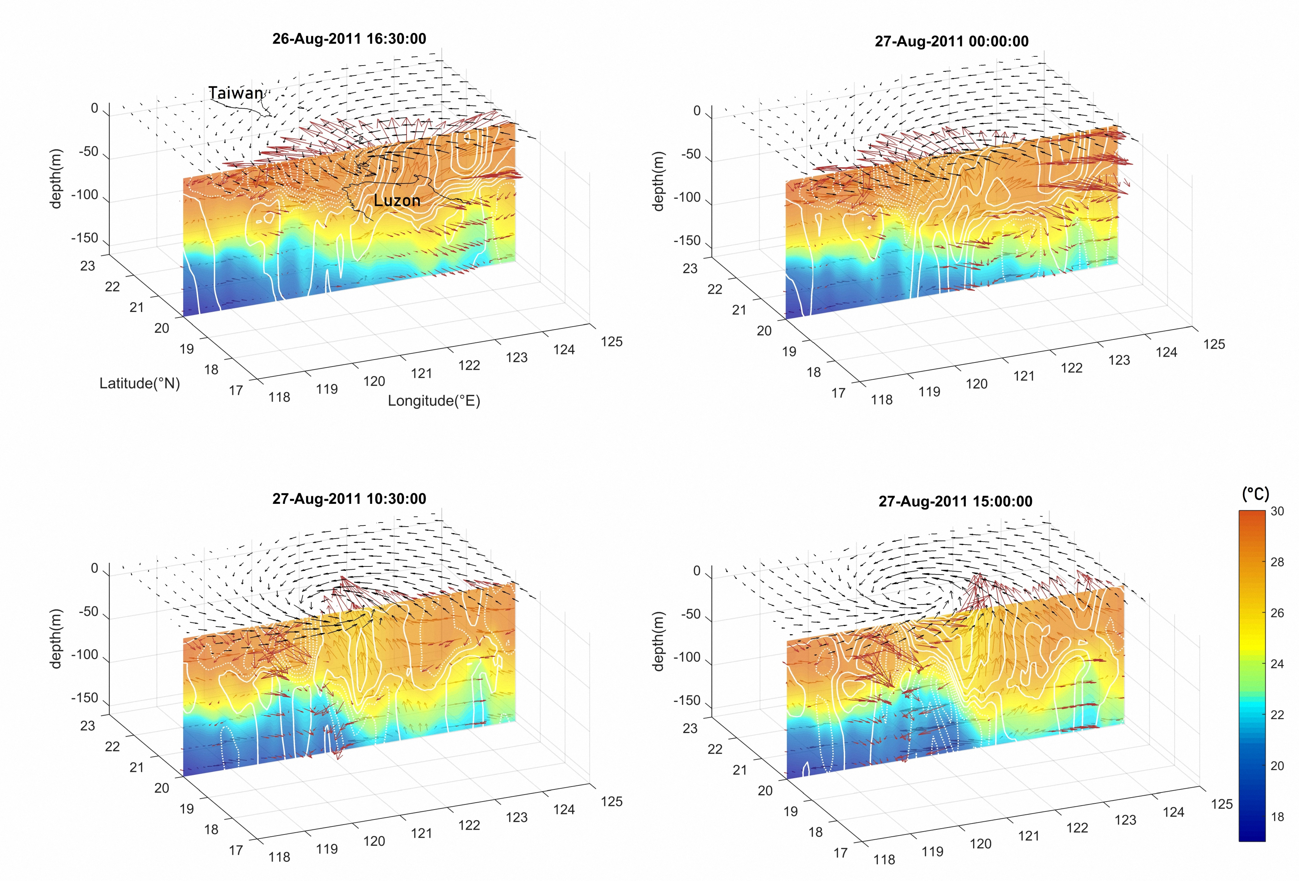
Figure 12. the COAWST model results showing the air-sea interactions during typhoon Nanmadol (2011).
3-2 The metocean data for the long-term design
- Severe events
Severe events resulting in the intensive wind, storm surge, and dramatic deformation of sea bedform affect the security design of offshore wind turbine. The wind farm on the site 18/19 suffers from the typhoons frequently. Figure 13 shows the categories of typhoon pathway around Taiwan. From 2008 to 2018, fifty-five typhoons approached Taiwan, in which twenty-one of them pass through Taiwan Strait.
In order to evaluate the impact of severe events on the offshore windfarm, some representative hindcasting simulation will be conducted to calibrate and validate the performance of the coupled COAWST model. In addition, the accuracy of the modelling system will be evaluated by the comparison with the real-time integrated observational platform in the next few years. Then, we can build up some databases based on these simulations of the severe events and the observational platform.
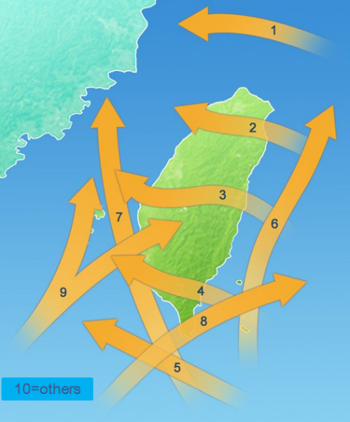
Figure 13. the category of typhoon pathway through Taiwan
- Environmental long-term evolution
The life cycle of offshore wind farm in Taiwan is designed for around 25 years. The terrain under the windfarm and the nearby environment may likely evolve into a different stage which is far from the initial designed condition and may potentially damages the security of wind turbine foundation. The potential of environmental long-term evolution would be investigated by an ensemble simulation with a wild range of environment parameters.
3-3 Real-time forecasting system
- Estimate the daily production to the power grid
The real-time forecast tools have been wildly used by the wind power plant operators in some electricity markets, such as France, the Netherlands or Belgium, to participate in intra-day trading (Valldecabres et al., 2018, Xydas et al., and Alessandrini et al., 2014). In the case of Taiwan, the real-time forecast system is a powerful tool to estimate the daily or hourly wind energy production into the power grid. The wind power plant managers referring to the forecast system could adjust the wind power operation to maximize the benefits or minimize the potential loss.
- Highlight the potential risk
It’s expansive to monitor the windfarm area from atmosphere, ocean to the sea bed during the storm events. The real-time forecasting system is economical to highlight the potential risk of windfarm against the incoming storm and control the cost of maintenance.

Reference
Alessandrini S, Davo F, Sperati S, Benini M, Delle Monache L, 2014, Comparison of the economic impact of different wind power forecast system for producers, Advances in Science and Research, 11:49-53
Chang, Y. C., Tseng, R. S., Centurioni, L. R. ,2010,. Typhoon-induced strong surface flows in the Taiwan Strait and Pacific. Journal of oceanography, 66(2), 175-182.
Fang, Y. C., J. Wang, Y. J. Yang, J. C. Mau, K. H. Thia, and M. J. Huang, 2011, Preliminary results of CODAR surface current observations northeast of Taiwan. 2011 International Workshop on Operating System from Marine Environment Monitoring and Forecasting, Kaohsiung, Taiwan, 59-77
He, X., Bai, Y., Chen, C. T. A., Hsin, Y. C., Wu, C. R., Zhai, W., ... Gong, F., 2014, Satellite views of the episodic terrestrial material transport to the southern Okinawa Trough driven by typhoon. Journal of Geophysical Research: Oceans, 119(7), 4490-4504.
Jan, S., Chern, C. S., Wang, J., Chao, S. Y., 2004, The anomalous amplification of M2 tide in the Taiwan Strait, Geophysical Research Letters, 31(7).
Jan, Sen, et al. , 2015, "Large variability of the Kuroshio at 23.75 N east of Taiwan." Journal of Geophysical Research: Oceans 120.3 : 1825-1840.
Jaynes D W, McGowan J G., Rogers A L., Manwell J F, 2007 June, Validation of Doppler LIDAR for Wind Resource Assessment Applications, AWEA Windpower2007 Conference, Los Angeles, CA.
Kuo, T. H., Wang, J., Liang, W. D., Fang, Y. C., & Yang, Y. J. ,2014 April, Surface currents observed by the HF radar Northeast of Taiwan. In OCEANS 2014-TAIPEI (pp. 1-4). IEEE.
Kuo, Yi-Chun, et al., 2018, "Typhoon–Kuroshio interaction in an air–sea coupled system: Case study of Typhoon Nanmadol (2011)." Ocean Modelling.
Standridge C R, Zeitler D, Nordman E, Boezaart T A, Edmonson J, Nieves Y, et al., 2013, "Laser Wind Sensor Performance Validation with an Existing Gage" Offshore Wind Project at ScholarWorks@GVSU http://scholarworks.gvsu.edu/windreports/2.
Valldecabres L., Nygaard N.G., von Bremen L., and Kuhn M., 2018, Very shor-term probabilistic forecasting of wind power based on dual-Doppler radar measurements in the North Sea, Journal of Physics: Conf. series, 1037:052010.
Xydas E, Qadrdan M, Marmaras C, Cipcigan L, Jenkins N and Ameli H, 2017, Probabilistic wind power forecasting and its application in the scheduling of gas-fired, Applied Energy, 192:382-394
Yu, X., Pan, W., Zheng, X., Zhou, S., Tao, X., 2017, Effects of wave-current interaction on storm surge in the Taiwan Strait: Insights from Typhoon Morakot, Continental Shelf Research, 146, 47-57.
Zhang, W. Z., Shi, F., Hong, H. S., Shang, S. P., Kirby, J. T. , 2010, Tide‐surge interaction intensified by the Taiwan Strait. Journal of Geophysical Research: Oceans, 115(C6).

